Proposal to Create a Plants, Nature and Health Initiative or Institute

Contacts: Jay Maddock, maddock@tamu.edu; Charlie Hall c-hall@tamu.edu

Goal: For Texas A&M to become the worldwide leader in multidisciplinary research and outreach in the health benefits of plants and nature.

Product: A strategic plan with an analysis of the competitive landscape, strategic vision, and achievable milestones to meet the goal stated above.

Background: Since the COVID-19 pandemic, there has been a surge of research examining the health promoting benefits of plants and nature on human health. This has been seen nationally through the White House led first national nature assessment and the creation of the Nature and Health Alliance. Globally, Kate Middleton has decided to focus her royal duties promoting health benefits of spending time in nature.

If it were to capitalize on the synergies that exist among TAMU colleges, departments, and AgriLife agencies, such interdisciplinary efforts would uniquely position Texas A&M University as the leading university globally studying this relationship.

Currently, TAMU has numerous internal and external partners to move this initiative forward. Leadership is anchored in two current entities: The Center for Health & Nature, a collaborative center shared by TAMU Health, Houston Methodist and Texan by Nature housed in the School of Public Health and the Ellison Endowed Chair in International Floriculture housed in the Department of Horticultural Sciences.

Numerous other internal research and outreach partners include faculty and experts associated with the Benz School of Floral Design, University Health Services; the Human Behavior Lab; the Department of Hospitality, Hotel Management, & Tourism; the Department of Landscape Architecture and Urban Planning; the Center for Health Systems & Design; the Department of Agricultural Leadership, Education, and Communication; the Texas A&M Health Science Center; Texas A&M Forest Service, the Department of Psychological and Brain Sciences; the Master Gardener and Junior Master Gardener network; Healthy Texas; Better Living for Texans; the Institute for Advancing Health Through Agriculture, the Aplin Center; and The Gardens and Aggie Park.

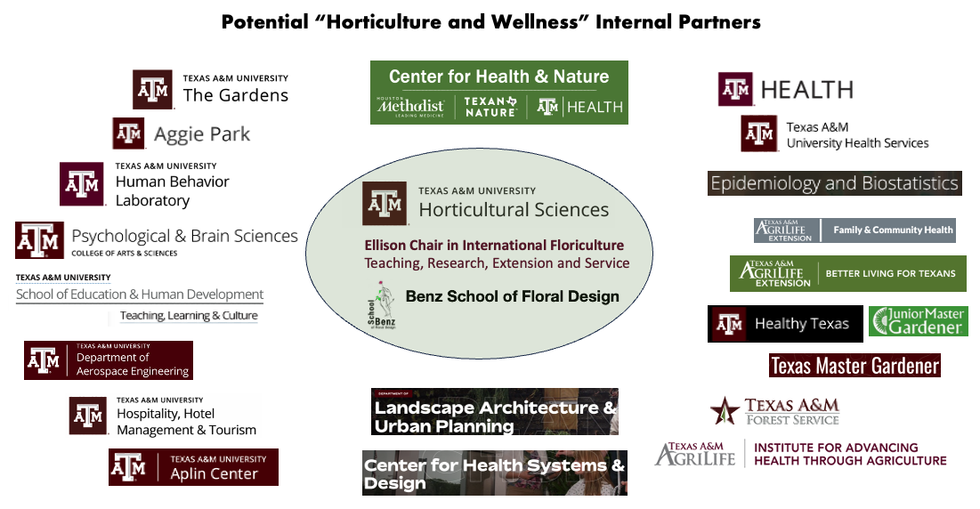
Potential external partners include the Texas Department of Agriculture, the Nature and Health Alliance, REI Cooperative Action Fund, the Lower Colorado River Authority, Texas Parks and Wildlife, Texas Department of State Health Services, America in Bloom, Houston Methodist, Texas Children & Nature Network, The Texas Nursery and Landscape Association, Texas Children in Nature Network, Texan by Nature, and the Texas State Florists Association.
A brainstorming meeting was held in October 2023 as part of the Ellison Chair Distinguished Lecture series that brought together representatives from the internal TAMU departments and AgriLife agencies, as well as key external partners. While 207 unique ideas were generated from that meeting, a prioritization process narrowed the list to a subset of about two dozen projects that were then further prioritized to seven focal areas on which to move forward. Central to these seven focal areas was the development of a university-wide initiative or institute that would capture the synergies of the research and outreach currently by the internal and external partners identified.

While a few collaborative efforts have already resulted from that meeting, we have created a “think tank” steering committee to: (1) conduct a thorough assessment of the resources and capabilities of internal and external partners in the plant, nature, and health arena, and (2) hold a formal strategic planning process to assess the preferred mechanism(s) for moving these initiatives forward. The initial steering committee members include:

- Jay Maddock, Environmental and Occupational Health
- Charlie Hall, Horticultural Sciences
- Amit Dhingra, Horticultural Sciences
- Marco Palma, Agricultural Economics
- Mike Arnold, Director, TAMU Gardens, Professor, Dept of Horticultural Sciences
- Scott Shafer, Campus and Community Enrichment within the Office of the President
- Debra Kellstedt, AgriLife Extension
- Rebecca Seguin-Fowler, Institute for Advancing Health through Agriculture/Nutrition
- PJ Ellison, External Advisor
- John Dole, NC State University
- Ryan Heare, Office of Lois Kolkhorst, State Senator, Mental health policy for the Health and Human Services Committee

In addition to the initial steering committee members, other participants in the October 2023 brainstorming session that had expressed an interest in participating in this focal area included:

- Renee Abbott, Doctoral student in the Department of Aerospace Engineering
- Nancy Fehrenwald, Associate Vice President, University Health Services, Texas A&M Health
- Zienna Blackwell, Director, Prevention & Population Health, University Health Services
- Chanam Lee, Professor and Coordinator of Ph.D. Program in Urban and Regional Sciences, Department of Landscape Architecture & Urban Planning, Center for Health Systems & Design
- Jodi Nerren, Assistant Professor & Extension Specialist – Early Childhood Health & Safety, Family & Community Health Unit, Texas A&M AgriLife Extension
- Morgan Abbott, Regional Woodland Ecologist, Urban & Community Forestry, Texas A&M Forest Service
- Courtney Suess, Associate Professor, Dept of Hospitality, Hotel Management, and Tourism; Medical Tourism and Healthcare Facility Development, Center for Health Systems & Design
- Arianna Pikus, School of Education and Human Development - Teaching, Learning, & Culture (nature-based learning)
- Neil Peltier, Associate Director, Aggie Park
- Jade Wu, Assistant Professor and Extension Specialist, Department of Family and Community Health | Texas A&M AgriLife Extension
- Lindsay Sansom, Research Assistant Professor, Department of Environmental and Occupational Health | School of Public Health
- Lynn Varton, Percussion Interarts Performance, College of Performance, Visualization & Fine Arts
- Garrett Sansom, Assistant Professor, Environmental and Occupational Health

